**The Scythe:**

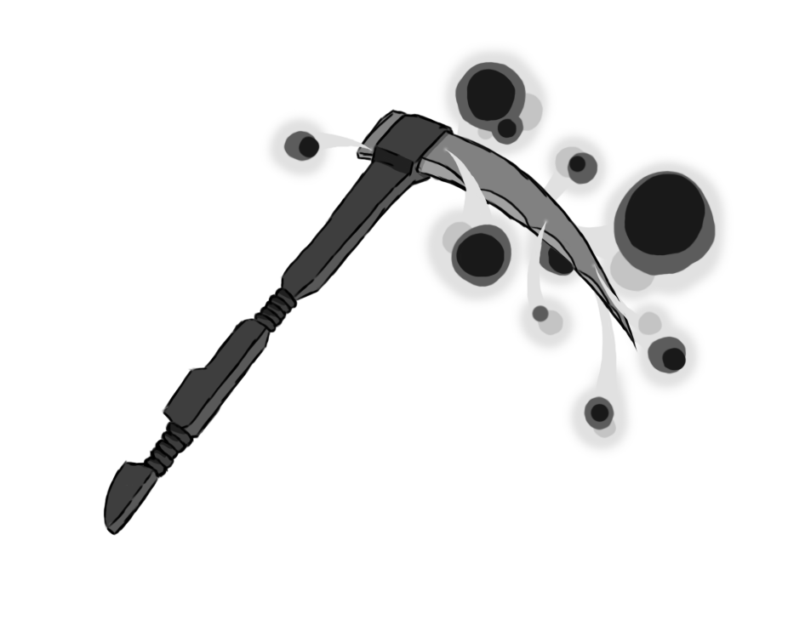

Figure 1 - Weapon: Scythe

**Brief Synopsis**

The scythe is an area of effect-based weapon used by the player. The main use of this weapon are its large hitboxes and **life-steal** ability on kill. This can be used in tandem with weak enemies to recover health without much danger. The weapon, however, does have its drawbacks. With each swing the player commits wildly to the attack, having large amounts of ending lag in the animation, leaving the player vulnerable.

**Special Ability**

**Zipline:  
 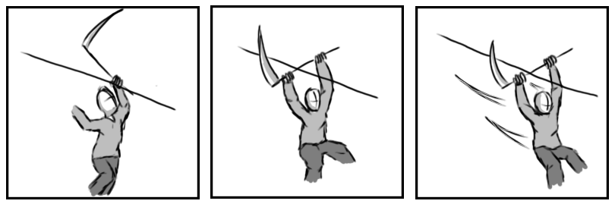**

Figure 2 - Animation Storyboard: Zipline

**Special:** Upon unlocking this weapon, the player will be able to latch onto the any zipline and slide down it by hooking the scythe around the wire.

**Combat Abilities**

**Jab:  
 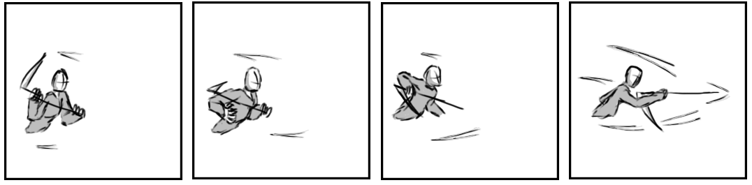**

Figure 3 - Animation Storyboard: Jab

**While grounded and stationary**: The player lunges forward with the scythe, using it to stab in front of them.

**Lesser Slash:  
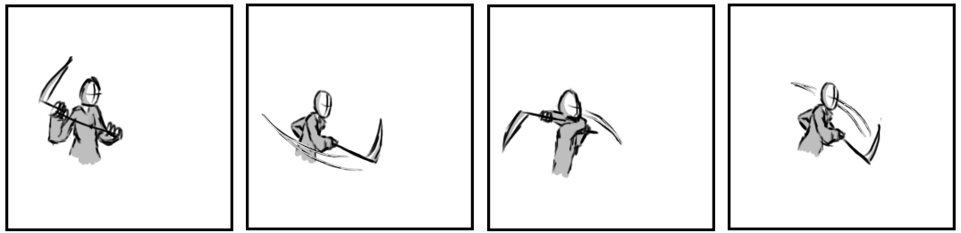**

Figure 4 - Animation Storyboard: Lesser Slash

**While grounded and in motion:** The player raises their scythe and swings it horizontally in front of them, before swinging the scythe again back to original side while staggering forwards.

**Greater Slash:   
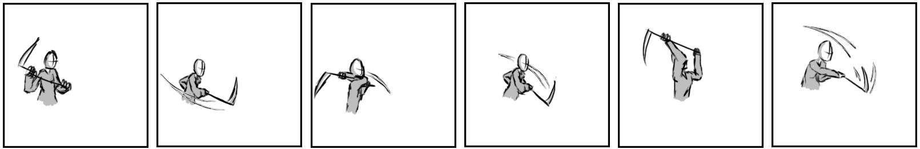**

Figure 5 - Animation Storyboard: Greater Slash

**While aerial:** An aerial version of the lesser slash. Each swing will be angled towards the closest enemy within range, ensuring it hits. The two swings of the lesser slash are followed up with a downward swing attacking vertically in front of the player.